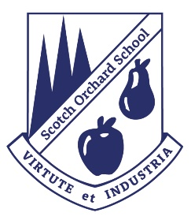
Scotch Orchard Primary School
SUN PROTECTION

Rationale:
We are all very aware that too much exposure to ultraviolet light (UV) radiation from the sun causes sunburn, skin damage and increases the risk of skin cancer. We are committed to keeping our pupils safe while they are at school and want them to be informed about keeping themselves safe in the sun.
School Uniform:
Children should bring in and wear hats that protect their face, neck and ears such as legionnaire or bucket hats for when they are outside. Sunglasses are also recommended.
Children are not permitted to wear vest style tops for P.E.
Covering up, seeking shade and drinking water:
We have some sheltered and shady areas in school which the children will be directed to on very hot and sunny days.
Timetables and school routines will be altered on very hot/sunny days e.g. children will only be allowed out for 10 minutes at a time; scheduled outdoor P.E. session/sporting activities will take place indoors or be cancelled
Children have unlimited access to water in school every day. We ask that parents provide clean non-spill plastic bottles so that they can be re-filled as necessary –these should be clearly labelled with the child’s name.
Applying sunscreen at home:
Parents/carers are asked to apply long lasting high factor (SPF 15 or above) sunscreen in the morning, paying particular attention to exposed areas such as lower arms/hands/lower legs, faces and necks.
We do not permit children to bring sunscreen into school. This is for health and safety reasons- e.g. allergic reactions/ accidental ingestion.

